**Министерство науки и высшего образования Российской Федерации** **Федеральное государственное бюджетное образовательное учреждение высшего образования** **«Московский государственный технический университет** **имени Н.Э. Баумана** 

**(национальный исследовательский университет)»**

**(МГТУ им. Н.Э. Баумана)**

**Факультет «Информатика и системы управления»**

**Кафедра ИУ5 «Системы обработки информации и управления»**

Курс «Технологии машинного обучения»

Лабораторная работа №4

Выполнил:

студент группы ИУ5-63Б

Комаров Д. С.

Проверил:

Гапанюк Ю. Е.

2024 г.

**Ход работы:**

Загрузка датасета

**import** pandas **as** pd  
**import** seaborn **as** sns  
**import** matplotlib.pyplot **as** plt  
**import** numpy **as** np  
**from** sklearn.preprocessing **import** PolynomialFeatures, MinMaxScaler, StandardScaler  
**from** sklearn.linear_model **import** LinearRegression, Lasso, Ridge  
**from** sklearn.tree **import** DecisionTreeRegressor, export_graphviz, export_text  
**from** sklearn.svm **import** SVR  
**from** sklearn.metrics **import** r2_score, mean_squared_error, mean_absolute_error  
**from** sklearn.model_selection **import** train_test_split, GridSearchCV  
**from** IPython.display **import** Image  
**from** IPython.core.display **import** HTML  
**from** sklearn.preprocessing **import** OneHotEncoder  
**from** sklearn.preprocessing **import** OrdinalEncoder,LabelEncoder,StandardScaler  
**from** sklearn.pipeline **import** make_pipeline  
**from** sklearn.impute **import** SimpleImputer  
**from** sklearn.compose **import** make_column_transformer  
**from** sklearn.model_selection **import** train_test_split

data = pd.read_csv('sample_data/cleaned_all_phones.csv')  
data.head()

{"type":"dataframe","variable_name":"data"}

data.info()

<class 'pandas.core.frame.DataFrame'>  
RangeIndex: 1512 entries, 0 to 1511  
Data columns (total 22 columns):  
 # Column Non-Null Count Dtype   
--- ------ -------------- -----   
 0 phone_name 1512 non-null object   
 1 brand 1512 non-null object   
 2 os 1512 non-null object   
 3 inches 1512 non-null float64  
 4 resolution 1512 non-null object   
 5 battery 1512 non-null int64   
 6 battery_type 1512 non-null object   
 7 ram(GB) 1512 non-null int64   
 8 announcement_date 1512 non-null object   
 9 weight(g) 1512 non-null float64  
 10 storage(GB) 1512 non-null int64   
 11 video_720p 1512 non-null bool   
 12 video_1080p 1512 non-null bool   
 13 video_4K 1512 non-null bool   
 14 video_8K 1512 non-null bool   
 15 video_30fps 1512 non-null bool   
 16 video_60fps 1512 non-null bool   
 17 video_120fps 1512 non-null bool   
 18 video_240fps 1512 non-null bool   
 19 video_480fps 1512 non-null bool   
 20 video_960fps 1512 non-null bool   
 21 price(USD) 1512 non-null float64  
dtypes: bool(10), float64(3), int64(3), object(6)  
memory usage: 156.6+ KB

**Чистка данных**

*# проверим есть ли пропущенные значения*  
data.isnull().sum()

phone_name 0  
brand 0  
os 0  
inches 0  
resolution 0  
battery 0  
battery_type 0  
ram(GB) 0  
announcement_date 0  
weight(g) 0  
storage(GB) 0  
video_720p 0  
video_1080p 0  
video_4K 0  
video_8K 0  
video_30fps 0  
video_60fps 0  
video_120fps 0  
video_240fps 0  
video_480fps 0  
video_960fps 0  
price(USD) 0  
dtype: int64

data[['width', 'height']] = data.resolution.str.split('x', expand = True).astype('int64')  
  
data.head()

{"type":"dataframe","variable_name":"data"}

data['announcement_year'] = data.announcement_date.apply(**lambda** x: x.split('-')[0]).astype('int64')  
data.head()

{"type":"dataframe","variable_name":"data"}

data.drop(columns = ['announcement_date', 'resolution', 'phone_name'], inplace = True)

data.describe()

{"summary":"{\n \"name\": \"data\",\n \"rows\": 8,\n \"fields\": [\n {\n \"column\": \"inches\",\n \"properties\": {\n \"dtype\": \"number\",\n \"std\": 532.5310851556795,\n \"min\": 0.4770430982109062,\n \"max\": 1512.0,\n \"num_unique_values\": 8,\n \"samples\": [\n 6.4224603174603185,\n 6.5,\n 1512.0\n ],\n \"semantic_type\": \"\",\n \"description\": \"\"\n }\n },\n {\n \"column\": \"battery\",\n \"properties\": {\n \"dtype\": \"number\",\n \"std\": 2148.127173043608,\n \"min\": 784.6070221906537,\n \"max\": 7250.0,\n \"num_unique_values\": 8,\n \"samples\": [\n 4389.798941798942,\n 4500.0,\n 1512.0\n ],\n \"semantic_type\": \"\",\n \"description\": \"\"\n }\n },\n {\n \"column\": \"ram(GB)\",\n \"properties\": {\n \"dtype\": \"number\",\n \"std\": 531.8729184957466,\n \"min\": 1.0,\n \"max\": 1512.0,\n \"num_unique_values\": 7,\n \"samples\": [\n 1512.0,\n 6.6838624338624335,\n 8.0\n ],\n \"semantic_type\": \"\",\n \"description\": \"\"\n }\n },\n {\n \"column\": \"weight(g)\",\n \"properties\": {\n \"dtype\": \"number\",\n \"std\": 482.7337788722055,\n \"min\": 26.20011485546831,\n \"max\": 1512.0,\n \"num_unique_values\": 8,\n \"samples\": [\n 187.6362433862434,\n 187.0,\n 1512.0\n ],\n \"semantic_type\": \"\",\n \"description\": \"\"\n }\n },\n {\n \"column\": \"storage(GB)\",\n \"properties\": {\n \"dtype\": \"number\",\n \"std\": 507.5688180604079,\n \"min\": 1.0,\n \"max\": 1512.0,\n \"num_unique_values\": 7,\n \"samples\": [\n 1512.0,\n 109.16468253968254,\n 128.0\n ],\n \"semantic_type\": \"\",\n \"description\": \"\"\n }\n },\n {\n \"column\": \"price(USD)\",\n \"properties\": {\n \"dtype\": \"number\",\n \"std\": 803.235184359574,\n \"min\": 40.0,\n \"max\": 2300.0,\n \"num_unique_values\": 8,\n \"samples\": [\n 337.8470357142857,\n 260.0,\n 1512.0\n ],\n \"semantic_type\": \"\",\n \"description\": \"\"\n }\n },\n {\n \"column\": \"width\",\n \"properties\": {\n \"dtype\": \"number\",\n \"std\": 1117.8750058935389,\n \"min\": 253.48894039516676,\n \"max\": 3840.0,\n \"num_unique_values\": 7,\n \"samples\": [\n 1512.0,\n 1035.212962962963,\n 1080.0\n ],\n \"semantic_type\": \"\",\n \"description\": \"\"\n }\n },\n {\n \"column\": \"height\",\n \"properties\": {\n \"dtype\": \"number\",\n \"std\": 1057.435936394939,\n \"min\": 469.73457812549356,\n \"max\": 3840.0,\n \"num_unique_values\": 7,\n \"samples\": [\n 1512.0,\n 2207.190476190476,\n 2400.0\n ],\n \"semantic_type\": \"\",\n \"description\": \"\"\n }\n },\n {\n \"column\": \"announcement_year\",\n \"properties\": {\n \"dtype\": \"number\",\n \"std\": 710.6079645347033,\n \"min\": 1.7001902014840866,\n \"max\": 2023.0,\n \"num_unique_values\": 8,\n \"samples\": [\n 2020.4100529100529,\n 2021.0,\n 1512.0\n ],\n \"semantic_type\": \"\",\n \"description\": \"\"\n }\n }\n ]\n}","type":"dataframe"}

categorical_cols = list(data.select_dtypes(include='object').columns)  
onehot = OneHotEncoder(sparse_output=False)  
encoded = onehot.fit_transform(data[categorical_cols])  
encoded_cols = onehot.get_feature_names_out()  
encoded_df = pd.DataFrame(encoded, columns=encoded_cols)

encoded_df

{"type":"dataframe","variable_name":"encoded_df"}

final_df = pd.concat([data, encoded_df], axis=1).drop(columns=categorical_cols)

final_df

{"type":"dataframe","variable_name":"final_df"}

bool_cols = list(data.select_dtypes(include='bool').columns)  
final_df[bool_cols] = final_df[bool_cols].replace({True: 1, False: 0})

final_df.info()

<class 'pandas.core.frame.DataFrame'>  
RangeIndex: 1512 entries, 0 to 1511  
Data columns (total 68 columns):  
 # Column Non-Null Count Dtype   
--- ------ -------------- -----   
 0 inches 1512 non-null float64  
 1 battery 1512 non-null int64   
 2 ram(GB) 1512 non-null int64   
 3 weight(g) 1512 non-null float64  
 4 storage(GB) 1512 non-null int64   
 5 video_720p 1512 non-null int64   
 6 video_1080p 1512 non-null int64   
 7 video_4K 1512 non-null int64   
 8 video_8K 1512 non-null int64   
 9 video_30fps 1512 non-null int64   
 10 video_60fps 1512 non-null int64   
 11 video_120fps 1512 non-null int64   
 12 video_240fps 1512 non-null int64   
 13 video_480fps 1512 non-null int64   
 14 video_960fps 1512 non-null int64   
 15 price(USD) 1512 non-null float64  
 16 width 1512 non-null int64   
 17 height 1512 non-null int64   
 18 announcement_year 1512 non-null int64   
 19 brand_Apple 1512 non-null float64  
 20 brand_Google 1512 non-null float64  
 21 brand_Honor 1512 non-null float64  
 22 brand_Huawei 1512 non-null float64  
 23 brand_LG 1512 non-null float64  
 24 brand_Lenovo 1512 non-null float64  
 25 brand_OnePlus 1512 non-null float64  
 26 brand_Oppo 1512 non-null float64  
 27 brand_Realme 1512 non-null float64  
 28 brand_Samsung 1512 non-null float64  
 29 brand_Sony 1512 non-null float64  
 30 brand_Vivo 1512 non-null float64  
 31 brand_Xiaomi 1512 non-null float64  
 32 os_Android 1512 non-null float64  
 33 os_Android 10 1512 non-null float64  
 34 os_Android 10/ Android 11 1512 non-null float64  
 35 os_Android 11 1512 non-null float64  
 36 os_Android 12 1512 non-null float64  
 37 os_Android 12 or 13 1512 non-null float64  
 38 os_Android 12L 1512 non-null float64  
 39 os_Android 13 1512 non-null float64  
 40 os_Android 5.1 1512 non-null float64  
 41 os_Android 6 1512 non-null float64  
 42 os_Android 6.0 1512 non-null float64  
 43 os_Android 6.0.1 1512 non-null float64  
 44 os_Android 7.0 1512 non-null float64  
 45 os_Android 7.0.1 1512 non-null float64  
 46 os_Android 7.1 1512 non-null float64  
 47 os_Android 7.1.1 1512 non-null float64  
 48 os_Android 7.1.2 1512 non-null float64  
 49 os_Android 8.0 1512 non-null float64  
 50 os_Android 8.0 Oreo 1512 non-null float64  
 51 os_Android 8.1 1512 non-null float64  
 52 os_Android 8.1 Oreo 1512 non-null float64  
 53 os_Android 9.0 1512 non-null float64  
 54 os_Android 9.0 Pie 1512 non-null float64  
 55 os_EMUI 12 1512 non-null float64  
 56 os_EMUI 13 1512 non-null float64  
 57 os_Tizen 3.0 1512 non-null float64  
 58 os_iOS 11 1512 non-null float64  
 59 os_iOS 11.1.1 1512 non-null float64  
 60 os_iOS 12 1512 non-null float64  
 61 os_iOS 13 1512 non-null float64  
 62 os_iOS 14.1 1512 non-null float64  
 63 os_iOS 15 1512 non-null float64  
 64 os_iOS 15.4 1512 non-null float64  
 65 os_iOS 16 1512 non-null float64  
 66 battery_type_Li-Ion 1512 non-null float64  
 67 battery_type_Li-Po 1512 non-null float64  
dtypes: float64(52), int64(16)  
memory usage: 803.4 KB

print('Признаки, имеющие максимальную по модулю корреляцию с ценой телефона')  
best_params = final_df.corr()['price(USD)'].map(abs).sort_values(ascending=False)[1:]  
best_params = best_params[best_params.values > 0.3]  
best_params

Признаки, имеющие максимальную по модулю корреляцию с ценой телефона

storage(GB) 0.354250  
width 0.338867  
video_4K 0.312411  
video_720p 0.310810  
Name: price(USD), dtype: float64

plt.figure(figsize=(14, 6))  
sns.heatmap(final_df[best_params.index].corr(), vmin=-1, vmax=1, cmap='coolwarm', annot=True)  
plt.show()

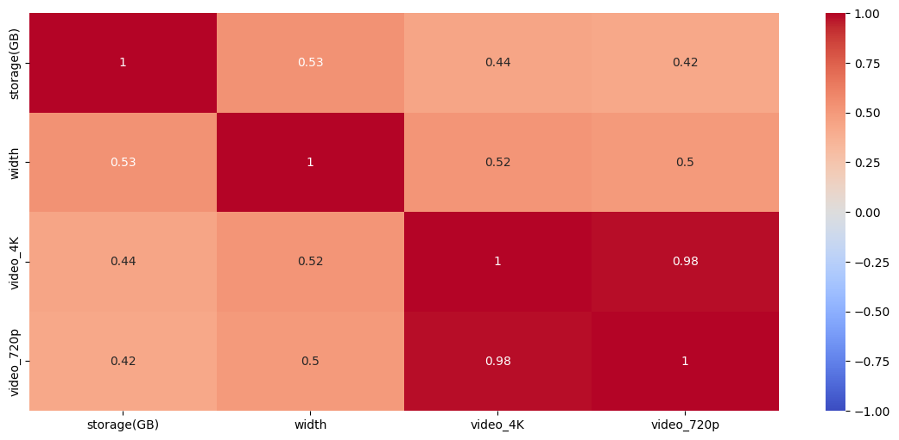

plt.figure(figsize=(6, 3))  
sns.heatmap(pd.DataFrame(data[np.append(best_params.index.values, 'price(USD)')].corr()['price(USD)'].sort_values(ascending=False)[1:]), vmin=-1, vmax=1, cmap='coolwarm', annot=True)  
plt.show()

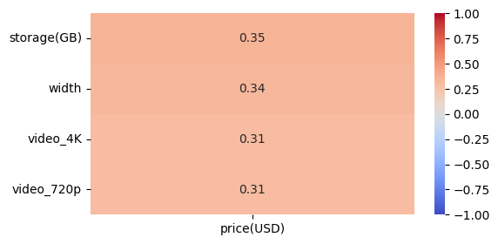

**Разделение выборки на обучающую и тестовую**

y = data['price(USD)']  
X = data[best_params.index]  
x_train, x_test, y_train, y_test = train_test_split(X, y, test_size=0.3, random_state=3)

**Линейная регрессия**

**def** print_metrics(y_test, y_pred):  
 *# коэффициент детерминации*  
 print(f"R^2: {r2_score(y_test, y_pred)}")  
 *# среднеквадратичная ошибка*  
 print(f"MSE: {mean_squared_error(y_test, y_pred)}")  
 *# средняя абсолютная ошибка*  
 print(f"MAE: {mean_absolute_error(y_test, y_pred)}")

linear_model = LinearRegression()  
linear_model.fit(x_train, y_train)  
y_pred_linear = linear_model.predict(x_test)  
print_metrics(y_test, y_pred_linear)

R^2: 0.13510555261347457  
MSE: 66433.49914733712  
MAE: 163.7848199812498

**Полиноминальная регрессия**

poly_model = PolynomialFeatures(degree=3)  
x_train_poly = poly_model.fit_transform(x_train)  
x_test_poly = poly_model.fit_transform(x_test)  
linear_model = LinearRegression()  
linear_model.fit(x_train_poly, y_train)  
y_pred_poly = linear_model.predict(x_test_poly)  
print_metrics(y_test, y_pred_poly)

R^2: -0.8520645814281242  
MSE: 142259.12903350135  
MAE: 179.1300123620549

**SVM**

scaler = StandardScaler().fit(x_train)  
x_train_scaled = pd.DataFrame(scaler.transform(x_train), columns=x_train.columns)  
x_test_scaled = pd.DataFrame(scaler.transform(x_test), columns=x_train.columns)  
x_train_scaled.describe()

{"summary":"{\n \"name\": \"x_train_scaled\",\n \"rows\": 8,\n \"fields\": [\n {\n \"column\": \"storage(GB)\",\n \"properties\": {\n \"dtype\": \"number\",\n \"std\": 373.8174690255228,\n \"min\": -1.4947908459995323,\n \"max\": 1058.0,\n \"num_unique_values\": 7,\n \"samples\": [\n 1058.0,\n -6.296160820180472e-17,\n 0.25100927754626334\n ],\n \"semantic_type\": \"\",\n \"description\": \"\"\n }\n },\n {\n \"column\": \"width\",\n \"properties\": {\n \"dtype\": \"number\",\n \"std\": 373.64275208677526,\n \"min\": -2.1055893753998194,\n \"max\": 1058.0,\n \"num_unique_values\": 7,\n \"samples\": [\n 1058.0,\n 2.5184643280721886e-16,\n 0.15328536075849372\n ],\n \"semantic_type\": \"\",\n \"description\": \"\"\n }\n },\n {\n \"column\": \"video_4K\",\n \"properties\": {\n \"dtype\": \"number\",\n \"std\": 373.97091200805585,\n \"min\": -1.046446130935795,\n \"max\": 1058.0,\n \"num_unique_values\": 5,\n \"samples\": [\n -4.53323579052994e-17,\n 0.9556153636936283,\n 1.0004729250678182\n ],\n \"semantic_type\": \"\",\n \"description\": \"\"\n }\n },\n {\n \"column\": \"video_720p\",\n \"properties\": {\n \"dtype\": \"number\",\n \"std\": 373.97376147434903,\n \"min\": -1.058414134902744,\n \"max\": 1058.0,\n \"num_unique_values\": 5,\n \"samples\": [\n -1.6453966943404966e-16,\n 0.9448097554856335,\n 1.0004729250678182\n ],\n \"semantic_type\": \"\",\n \"description\": \"\"\n }\n }\n ]\n}","type":"dataframe"}

params = {'C': np.concatenate([np.arange(0.1, 2, 0.1), np.arange(2, 15, 1)])}  
svm_model = SVR(kernel='linear')  
grid_cv = GridSearchCV(estimator=svm_model, param_grid=params, cv=10, n_jobs=-1, scoring='r2')  
grid_cv.fit(x_train_scaled, y_train)  
print(grid_cv.best_params_)

{'C': 8.0}

best_svm_model = grid_cv.best_estimator_  
best_svm_model = SVR(kernel='linear', C=8)  
best_svm_model.fit(x_train_scaled, y_train)  
y_pred_svm = best_svm_model.predict(x_test_scaled)  
print_metrics(y_test, y_pred_svm)

R^2: 0.09028888194733287  
MSE: 69875.91719208499  
MAE: 145.91318982938506

**Дерево решений**

params = {'min_samples_leaf': range(3, 30)}  
tree = DecisionTreeRegressor(random_state=3)  
grid_cv = GridSearchCV(estimator=tree, cv=5, param_grid=params, n_jobs=-1, scoring='neg_mean_absolute_error')  
grid_cv.fit(x_train, y_train)  
print(grid_cv.best_params_)

{'min_samples_leaf': 13}

best_tree = grid_cv.best_estimator_  
best_tree.fit(x_train, y_train)  
y_pred_tree = best_tree.predict(x_test)  
print_metrics(y_test, y_pred_tree)

R^2: 0.17201798017858494  
MSE: 63598.21475791498  
MAE: 152.63921401566597

importances = pd.DataFrame(data=zip(x_train.columns, best_tree.feature_importances_), columns=['Признак', 'Важность'])  
print('Важность признаков в дереве решений\n')  
**for** row **in** importances.sort_values(by='Важность', ascending=False).values:  
 print(f'{row[0]}: {round(row[1], 3)}')

Важность признаков в дереве решений  
  
width: 0.698  
video_720p: 0.197  
storage(GB): 0.104  
video_4K: 0.0

plt.figure(figsize=(12, 4))  
sns.barplot(data=importances.sort_values(by='Важность', ascending=False), y='Признак', x='Важность', orient='h', )  
plt.title('Важность признаков в дереве решений')  
plt.show()

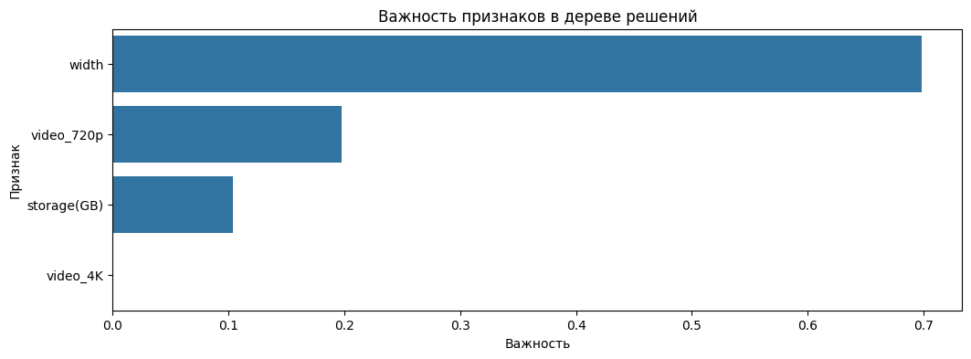

export_graphviz(best_tree, feature_names=best_params.index, filled=True, out_file='tree.dot')  
!dot -Tpng tree.dot -o tree.png  
Image(filename='tree.png')

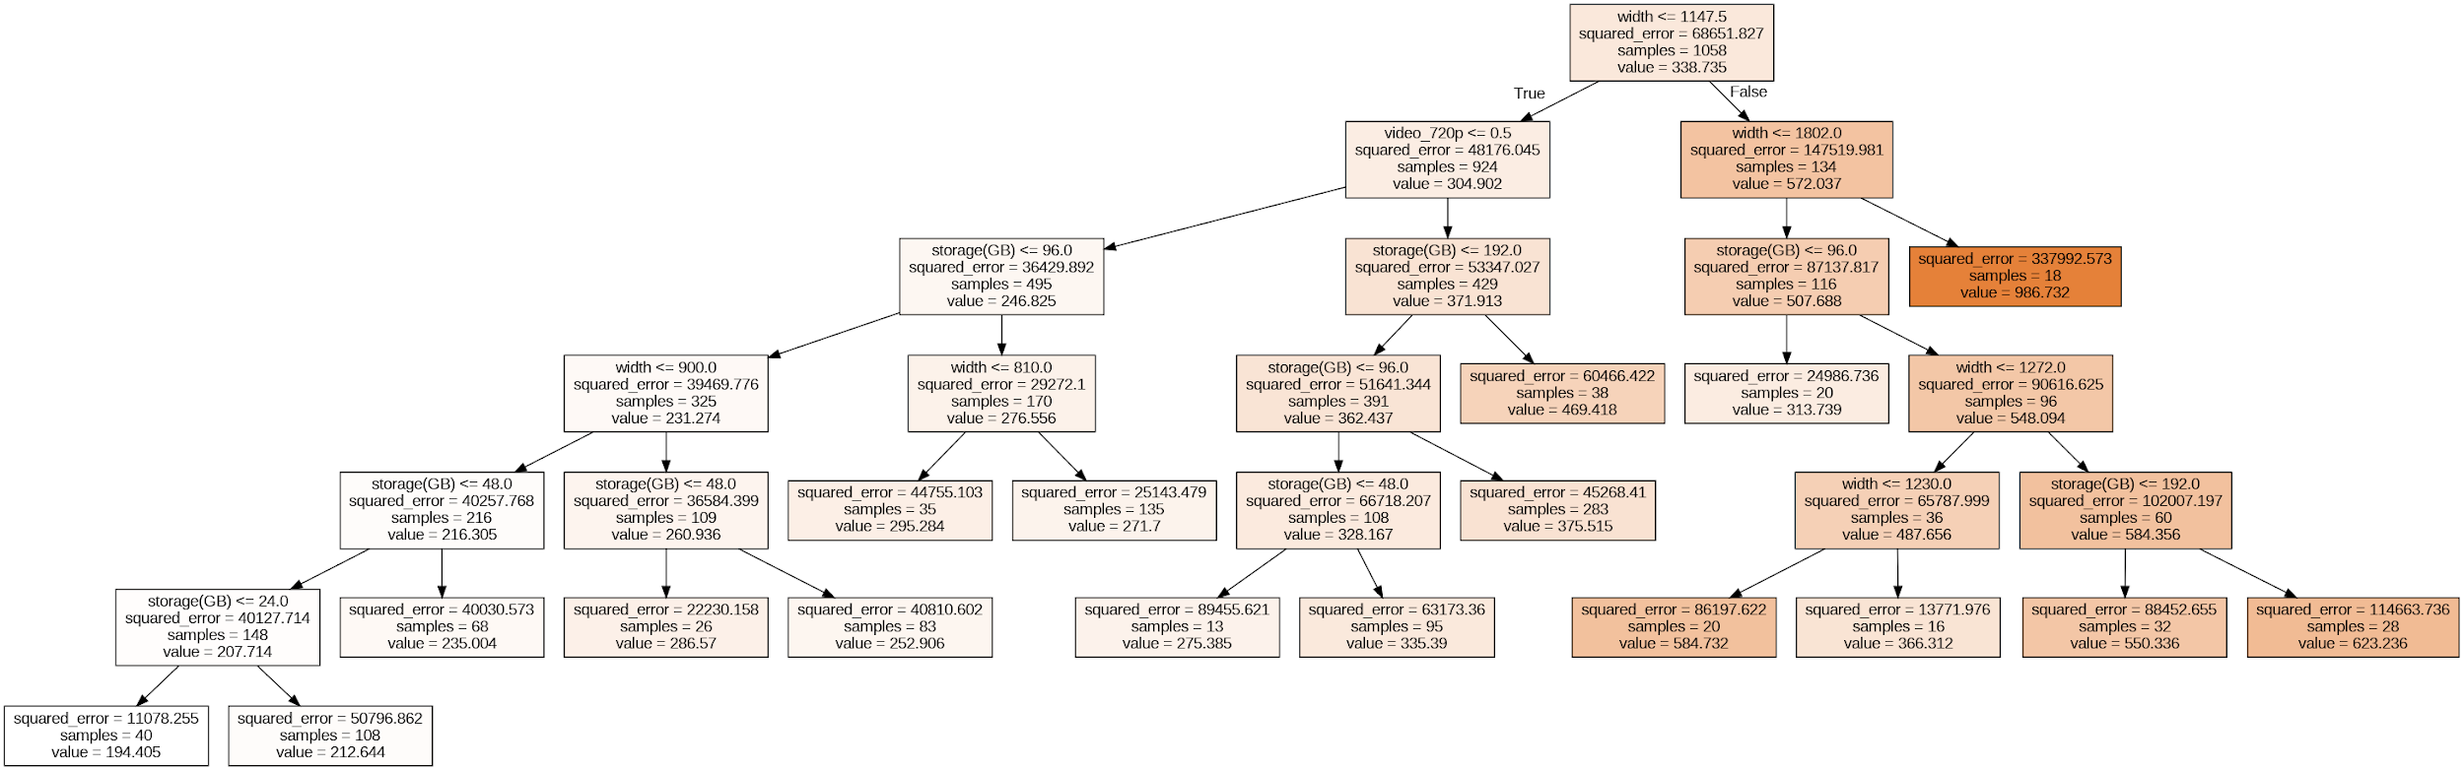

print('Линейная регрессия')  
print_metrics(y_test, y_pred_linear)  
  
print('\nПолиномиальная регрессия')  
print_metrics(y_test, y_pred_poly)  
  
print('\nМетод опорных векторов')  
print_metrics(y_test, y_pred_svm)  
  
print('\nДерево решений')  
print_metrics(y_test, y_pred_tree)

Линейная регрессия  
R^2: 0.13510555261347457  
MSE: 66433.49914733712  
MAE: 163.7848199812498  
  
Полиномиальная регрессия  
R^2: -0.8520645814281242  
MSE: 142259.12903350135  
MAE: 179.1300123620549  
  
Метод опорных векторов  
R^2: 0.09028888194733287  
MSE: 69875.91719208499  
MAE: 145.91318982938506  
  
Дерево решений  
R^2: 0.17201798017858494  
MSE: 63598.21475791498  
MAE: 152.63921401566597